Running Head: Invasive species tolerates low oxygen conditions

Title: Do low oxygen environments facilitate invasion? Relative tolerance of native and invasive species to low oxygen conditions

Marcelo E. Lagos 1,2, Diego R. Barneche 2, Craig R. White 1,2, & Dustin J. Marshall 2,3

1School of Biological Sciences, The University of Queensland, St Lucia, QLD 4072, Australia

2School of Biological Sciences/Centre for Geometric Biology, Monash University,

Clayton, VIC 3800, Australia

3 E-mail:  [dustin.marshall@monash.edu](mailto:dustin.marshall@monash.edu&subject=Enquiry%20submitted%20via%20MEEG%20website)

*Abstract.* Biological invasions are one of the biggest threats to global biodiversity. In marine systems, hard artificial structures disrupt water current flow while providing free space for invasive and native organisms to colonize. In low flow, the limited replenishment of oxygen together with the oxygen consumption of dense sessile communities can lead to the formation of hypoxic microenvironments. The extent to which native fauna can cope with such low oxygen conditions, and whether invasive species (long associated with such habitats) have adapted to these conditions remains unclear. We measured oxygen availability in marinas and piers at scales relevant to sessile marine invertebrates (mm), as well as water flow velocities adjacent to these structures. Using standard assays, we then measured the capacity of invasive and native marine invertebrates to maintain metabolic rates under decreasing levels of oxygen. Our findings indicate that marinas reduce the water flow relative to piers, and that local oxygen levels can be as low as zero in these low flow conditions. For the subset of species that have arborescent growth form, invasive species can tolerate significantly lower levels of oxygen relative to native species. Integrating the field and laboratory data showed that up to 30% of available habitat within low flow environments is physiologically stressful for native species, while only 18% of the habitat is physiologically stressful for invasive species. These results suggest that invasive species are better adapted to low oxygen habitats associated with manmade habitats, and artificial structures may be creating niche opportunities for the expansion of invasive species.

*Key words.**Non-indigenous species; sessile communities; sessile organisms; low flow; low oxygen; exploitative competition; invasions; artificial structures; marinas.*

INTRODUCTION

Biological invasions are considered, together with habitat destruction, to be one of the biggest threats to biodiversity around the world (Vitousek et al. 1996, Davis 2003, Dafforn et al. 2009a). The damage caused by non-indigenous species (NIS) can have far-reaching consequences for biodiversity. Beyond the obvious damage to natural systems, NIS can also negatively impact on human activities, increase disease proliferation, and damage agriculture (Mack et al. 2000, Pimentel et al. 2001). While some habitats are more susceptible than others, no habitat is immune to invasion (Shea and Chesson 2002). The invasion process is complex, largely because invasion success is determined by both the characteristics of the potentially invaded habitat, the traits of the invasive species, and the interaction between both habitat and the invasive species (Andow et al. 1990, Arim et al. 2006, van Kleunen et al. 2010a, van Kleunen et al. 2010b, Zhao and Feng 2015). Several hypotheses have been put forward to explain the role of the environment in determining the likelihood of invasions. Some focus on the characteristics of the environment only and others on species-habitat interactions, however most hypotheses invoke resource usage in one way or another (Simberloff and Von Holle 1999, Keane and Crawley 2002, Shea and Chesson 2002, Davies et al. 2005).

There are two broad classes of resource competition that can mediate invasion, and they relate to the type of competition that occurs. Invasion “from above” occurs when interference competition dominates, and species with large resource requirements are able to overcome limitations by seizing resources from established residents. On the other hand, invasion “from below”, occurs when exploitative competition dominates, and species with lower resource requirements are more successful because they use the few available resources in a more efficient way (Persson 1985, Crawley et al. 1986, Hart and Marshall 2012, Ferguson et al. 2013).

Resource availability and usage are therefore key elements of biological invasion. Environments may create “niche opportunities” in terms of resources that stimulate or limit invasions (Chesson 2000, Davies et al. 2005). When exploitative competition is important, the species that comes to dominate the community may be the one that can persist under the lowest resource levels (i.e. has the lowest R* value, sensu Tilman 2004), and displace all other species at equilibrium (Tilman 2004). Therefore potential NIS should be different enough from existing species to efficiently use unexploited resources. For example, the diatom *Didymosphenia geminata*, is highly invasive and appears to have a low R*, which allows it to outcompete native species in oligotrophic systems around the world (Sundareshwar et al. 2011, Cullis et al. 2012).

In marine systems, there is a strong association between artificial hard structures and invasive species. Commercial marinas and other artificial structures such as pilings, pontoons and jetties are considered windows for biological invasion (Bulleri and Airoldi 2005, Glasby et al. 2007, Dafforn et al. 2009b, Ruiz et al. 2009). Numerous hypotheses have been proposed for why artificial structures increase the likelihood of invasion. For example, propagule pressure is thought to be much higher around artificial structures; similarly, higher rates of pollution may facilitate invasion by pollution tolerant invaders (Kinlan and Gaines 2003, McKenzie et al. 2012, Erfmeier et al. 2013). In addition to these factors, artificial structures modify natural environments in ways that may facilitate invasion: by reducing wave exposure and water flow, they provide a sheltered habitat that nevertheless has plenty of hard surfaces available for colonization (Bulleri and Airoldi 2005, Clark and Johnston 2005, Glasby et al. 2007). We suspect that the reduction in water flow plays a key role in mediating the invasion of artificial structures by NIS.

Water flow is an important driver of community structure and composition in marine environments (Lastra et al. 2004, Palardy and Witman 2011). Water flow has a strong influence on the performance of sessile marine invertebrates as it affects the delivery of essential resources: food and oxygen (Okamura 1985, Shimeta and Jumars 1991, Gardella and Edmunds 1999, Lastra et al. 2004, Svensson and Marshall 2015). The interface between the fluid and a solid surface creates a condition known as a boundary layer, the thickness of which depends mostly on the flow of water. At small scales (mm’s), habitats with complex topography, as in sessile communities, generate a skimming flow that traps layers of water within the canopy increasing the residence time of the water, reducing exchange (Koch and Gust 1999). This boundary layer effect, in combination with the metabolic demands of the dense aggregation of sessile communities, can deplete oxygen levels in the water immediately surrounding benthic organisms (Moore et al. 1996, Ferguson et al. 2013). In some instances, oxygen levels can be so low that they fall below the physiological tolerance of some members of the communities (Ferguson et al. 2013). Importantly, growth form seems to be a strong determinant of tolerance to low oxygen conditions: species that have a flat growth form have much better tolerances to lower oxygen levels than species that have an erect growth form (Ferguson et al. 2013). Presumably these different tolerances reflect the fact that flat species are more likely to live entirely within the boundary layer, and are therefore more likely to experience low oxygen conditions, and have adapted accordingly. One can imagine that invasive species, with their long association with artificial structures, may have similarly adapted to low oxygen conditions but tests are lacking. One can hypothesize that NIS sessile marine invertebrates have lower resource requirement in terms of oxygen than native species because NIS have adapted to live in the low oxygen conditions that are typical of the low flow-high density communities that occupy artificial structures. In other words, we predict that NIS have a lower R* than native species in sessile marine invertebrate communities.

One way to estimate the R* for oxygen is to determine the level at which metabolic rates begin to drop with oxygen levels – i.e. the oxygen level at which an individual becomes an oxyconformer (Portner and Grieshaber 1993). In mammals, which are strong oxyregulators, this level is known as the critical oxygen concentration ($C_{C_{O_{2}}}$) or critical oxygen pressure ($P_{C_{O_{2}}}$); below that value, metabolic rate decreases, anaerobic mechanisms become more important, and conditions are considered physiologically stressful (Hochachka and Somero 2002, Armstrong et al. 2009). In marine invertebrates, which are often neither strict oxy-conformers nor oxy-regulators, measuring $C_{C_{O_{2}}}$ is less straightforward (see Methods), but the level at which metabolic rate declines with decreases in oxygen will estimate the capacity for maintaining biological processes in the face of low oxygen conditions. In terms of R*, species that are able to maintain higher levels of aerobic metabolism under lower oxygen conditions, will therefore have a competitive advantage over those that exhibit reduced metabolism at relatively higher oxygen conditions.

Here, we measure water flow rates and oxygen availability at small scales across 5 artificial structures that vary from relatively high flow environments (piers) to relatively low flow environments (marinas). Then we measured the oxygen tolerances of a range of NIS and native sessile marine invertebrates that grow on artificial structures. Because growth form strongly affects oxygen tolerance in this group, we also measured tolerances across species with erect growth forms and flat growth forms. Then we combined the field data and oxygen tolerance data to estimate the proportion of microhabitats habitats that are physiologically stressful for native versus non-indigenous species.

MATERIALS AND METHODS

*Study sites and species*

All flow and oxygen measurements were conducted at five sites within Port Phillip Bay, Victoria Australia; Blairgowrie Yacht Squadron (38° 21’ 22.44” S; 144° 46’ 22.12”), Royal Brighton Yacht Club (37° 54’25” S; 144° 58’ 52” E), Royal Melbourne Yacht Squadron (St Kilda) (31° 51’ 44.00”; 144° 57’ 53.12”), Queenscliff Harbour (38° 15’ 52.37” S; 144° 40’ 13.89”) and Queenscliff Pier (38° 15’ 47.35” S; 144° 40’ 6.20”). All the sites other than Queenscliff pier were sheltered by a breakwall, floating pontoons, or both.

*Field estimates of water flow velocity and oxygen availability*

We were interested in flow velocities at the scales and microsites that were relevant to the study organisms – the conditions just a few millimeters above the organisms. As such, we needed to use a more old-fashioned but reliable approach to measuring local flow speeds (Vogel 1994). To measure flow velocities adjacent to the study communities, we released 30 mL of milk among the sessile community and measured the distance (cm) from the point-source 30 and 60 seconds following release. Three replicate measures at each sampling location where taken, from which we calculated an average flow velocity (cm s-1) for each site.

To measure oxygen content in the water adjacent to the sessile community, we used fiber optic sensors connected to a fiber optic oxygen meter (Firesting; Pyro Sciences, Aachen-Germany). The sensors, that are a stainless tube of 10 cm with a sensor of 3 mm diameter on the tip, were calibrated using air saturated seawater (100% saturation) and seawater containing 2% sodium sulfite (0% saturation). After calibration the sensors were placed at 30 cm depth at 1 mm distance from benthic communities growing on the surface of floating pontoons and piers – for detailed methods see (Ferguson et al. 2013). For study sites within marinas, the oxygen availability from 12 regularly spaced sampling points was measured. At pier sites, we measured oxygen levels from three equidistant locations (~ 15 m apart). At each sampling location within each site, six replicate oxygen measures were taken, the duration of which lasted until oxygen readings had stabilized after the disturbance of introducing the probe had dissipated (approximately 5 - 10 minutes). To estimate temporal variability in flow and oxygen conditions at each site, we measured both flow velocities and oxygen levels on five noncontiguous days at each site.

*Organism collection and the estimation of tolerance to low oxygen conditions*

We collected specimens of larger species (e.g. solitary ascidians) by peeling adults from the floating pontoons. Smaller species (e.g. bryozoans and colonial ascidians) were collected from pre-roughened acetate sheets that had been deployed at field sites according to standard methods (Hart and Marshall 2009), for two years prior to the experiment. The species used in these studies were classified according to their status (i.e. native or invasive to Australia) and their growth form (i.e. erect or flat; Table 1). All of the species came from the same study sites so as to prevent confounding site of origin effects. The organisms were transported to the lab in insulated aquaria with aerated seawater and acclimatized to laboratory conditions for 2 days in the dark at 19 ˚C. Unfortunately, the sites we used only had two native species with a flat growth form so we could not formally compare invasive and native species with that growth form.

We measured oxygen consumption using two different closed respirometry systems, depending on the size of the study organism (Ferguson et al. 2013, Pettersen et al. 2015). Larger organisms were measured using hermetic 1.8 L chambers with circulating water connected to a 4-channel Firesting $O_{2}$ fiber optic oxygen meter (Pyro Sciences, Aachen-Germany). Smaller organisms were cut from acetate sheets and placed in 25 mL vials mounted on a 24-channel sensor dish reader (Sensor Dish Reader SDR, PreSens, Aachen- Germany). These systems were chosen because they do not consume oxygen, and have accurately estimated oxygen consumption and tolerance to low oxygen conditions for marine invertebrates in previous studies (Ferguson et al. 2013, Pettersen et al. 2015). The chambers and vials were filled with micro-filtered (0.2 μm), sterilized seawater that had been kept at 19 ˚C with constant aeration for at least 24 hours prior to experiments. Rates of oxygen consumption (, mL h-1) were calculated as described in previous studies (White et al. 2011, Ferguson et al. 2013, Pettersen et al. 2015). Dry mass was determined after the oxygen consumption trials by drying each organism in an oven at 60 ˚C for one week, then weighing each individual with a precision balance (Adventurer Pro OHAUS, New Jersey, USA) to the nearest milligram.

*Model*

In contrast to what is observed for most vertebrates, where a clear $C_{C_{O_{2}}}$ can be discerned (Marshall et al. 2013), our $\dot{V}O_{2}$ data were curvilinear, such that there was no clear point where the organisms transitioned from oxyregulator to oxyconformer. Instead we fit a Michaelis-Menten function to our $\dot{V}O_{2}$ consumption data:

$\dot{V}O_{2}=\frac{\dot{V}O_{2_{max}}×CO_{2}}{C_{50\%\dot{V}O_{2}}+CO_{2}}$, (1)

where $\dot{V}O_{2_{max}}$ is an asymptotic $\dot{V}O_{2}$, and $C_{50\%\dot{V}O_{2}}$ is the value of $CO_{2}$ where $\dot{V}O_{2_{max}}/2$. Importantly, in order to achieve model convergence, we employ a transformation to $\dot{V}O_{2}$. For each individual, we standardise $\dot{V}O_{2}$ based on its maximum value, so all individuals present a relative $\dot{V}O_{2}$ bounded between zero and one. We note that this transformation implicitly assumes that $C_{50\%\dot{V}O_{2}}$ is independent of body mass. While this transformation affects the estimated $\dot{V}O_{2_{max}}$, it does not affect our primary goal, which is to estimate $C_{50\%\dot{V}O_{2}}$ for each species.

*Model Fitting and statistical tests*

Sites were ranked according to the average of their water flow. The effects of water flow and time on oxygen availability in the field were analyzed using mixed linear models. Ranking of each site according to flow was a fixed factor and sampling location and time (day) were random factors.

For the $C_{50\%\dot{V}O_{2}}$ model, we fit equation (1) above in a Bayesian framework by calling *JAGS* version 4.2.0 from the R package *R2jags* version 0.05-6 (Su and Yajima 2015) in order to derive posterior distributions and associated 95% credible intervals (CIs) for the fitted parameters, $\dot{V}O_{2_{max}}$ and $C_{50\%\dot{V}O_{2}}$. We allow $\dot{V}O_{2_{max}}$ and $C_{50\%\dot{V}O_{2}}$ to vary randomly among species. Random effects were assumed to be normally distributed, with means of 0. Fitted parameters were assigned priors that were vague (i.e. locally uniform over the region supported by the likelihood) (Kruschke 2014). The posterior distributions of model parameters were estimated using Markov chain Monte Carlo (MCMC) methods by constructing three chains of 1.5 106 steps each, including 7.5 105-step burn-in periods. Chains were thinned using a 375-step interval, so a total of 6,000 steps were retained to estimate posterior distributions (i.e. 3 (1.5 106 - 7.5 105)/375 = 6,000).

We use the species-specific estimates (*n* = 14) for $C_{50\%\dot{V}O_{2}}$ obtained in *JAGS* in order to fit three separate ANOVA’s: one to test for differences in $C_{50\%\dot{V}O_{2}}$ between species status (native and invasive), a second to test for differences in $C_{50\%\dot{V}O_{2}}$ between species shape (erect and flat), and a third one to test for differences in $C_{50\%\dot{V}O_{2}}$ between species status of erect shaped organisms (native and invasive). Ideally, a fairer test would be represented by a two-way ANOVA with a formal statistical interaction between status and shape. However, given that we only have 14 species in our dataset, doing so would most likely overfit the data (i.e. too many parameters to be estimated from few observations), so our approach is conservative. We fit these ANOVA’s for each one of the 6,000 MCMC parameter estimates in order to obtain a full ‘posterior distribution’ of differences in $C_{50\%\dot{V}O_{2}}$ between categories (status or shape). Statistical significance is judged by the lack of overlap between the 95% credible intervals of such distributions.

We have also estimated the average point at which different species start displaying signs of stress due to decreasing oxygen availability. To do so, for each species, we use the average species-specific parameters from our Bayesian model in order to calculate the value of air saturation in which oxygen consumption is 5% lower than that at 100% air saturation.

RESULTS

*Field estimates of water flow and oxygen availability*

Flow velocities differed among marinas, with a significant effect of the interaction site, day and spot (*F*(44,693)= 2.287, *P*< 0.05). The sites with the lowest flow velocity were St. Kilda (1.4 ± 0.9 cm seg-1) and Brighton (1.5 ± 4.3 cm seg-1), followed by Queenscliff Harbor (3.5 ± 2.8 cm seg-1) and Blairgowrie (3.6 ± 2.8 cm seg-1). Queenscliff Pier had the highest flow compared to all other studies sites (19.0 ± 6.6 m seg-1). The rank order of flow conditions at any one site corresponded roughly with mean local oxygen availability although this effect was largely driven by 100% oxygen conditions at the site with the highest flow rates (Fig 1). Microsites (i.e. samples?!) with high oxygen levels (% air saturation) were found at all sites (Fig 1) but mean oxygen availability differed significantly among sites (*F*(4,1510)=31.02, *P*<0.05: Fig 1). St Kilda had the highest variation in oxygen availability and also had higher frequency of spots with 0 % of oxygen (Table 2, Fig 1). In contrast, Queenscliff Pier had the lowest variability in oxygen availability, and no microsite showed oxygen levels at 0 % (Table 2, Fig 1). At this site, the main source of variation in oxygen availability was microsite, and daily variation in oxygen availability was minimal (Table 2).

*Tolerance to low oxygen conditions*

Both the growth form of species and the status of species as native or invasive influenced their tolerance to low oxygen conditions: flat species tolerate oxygen levels that are 40% lower than the critical values for erect species (Fig 2A); similarly, invasive species tolerate oxygen levels that are 40% lower than the critical values for native species (Fig 2B). Unfortunately, we could not formally estimate the interaction between invasive status and growth form because we only had two flat native species in the dataset. Consequently, when we consider just the erect form, for which there were both multiple invasive and native species in the dataset, erect invasive species could tolerate significantly lower oxygen levels than erect native species (Figure 3).

When we combined the estimates of oxygen availability with the estimates of tolerance to low oxygen, we found that 22–30% of microsites fell below the tolerances of native species in low flow sites (St Kilda and Brighton) but only 12–18% of microsites were below the tolerance of invasive species. At the site with the second highest flow, only between 11% and 18% of microsites were unavailable to invasive and native species respectively. At the site with the highest flow, all of the microsites were habitable to species of both status types.

DISCUSSION

The results indicate that manmade structures, particularly marinas, modify the oxygen availability in marine environments, and in the most extreme cases, push oxygen levels below the tolerance of the species that could live there, particularly native species. Environments with high water flow provide almost exclusively normoxic microsites with low spatial and temporal variation in oxygen levels. On the other hand, low flow environments exhibit high variation in oxygen levels in both space and time. Flat species have greater tolerance to hypoxic conditions than erect species, a result that echoes previous studies in warm water sessile marine invertebrate communities (Ferguson et al. 2013). Most importantly, we found that invasive species can tolerate lower oxygen levels than native species – invasive species could maintain a $\dot{V}O_{2_{max}}/2$ at oxygen levels that were ~2-fold lower than those of native species. Based on the $C_{50\%\dot{V}O_{2}}$ values reported here, we calculated that in some sites, up to 30% of the habitat is physiologically stressful for native species.

Previous studies have record broad scale reductions in oxygen levels in low flow marinas (Stammerjohn et al. 1991), but few have explored oxygen levels at the scales that are likely to be relevant to organisms. The results are likely to slightly overestimate oxygen availability in the field. We measured oxygen during daylight hours and in regions that were exposed to ambient light. Oxygenation of the boundary layer from photosynthesis by micro-phyto-benthos will therefore increase local oxygen levels during the day relative to those same areas at night (for analogous effects in tide pools, coral reefs and low flow systems see (Kinsey and Kinsey 1967, Osinga et al. 1999, Nilsson and Ostlund-Nilsson 2004, Dodds et al. 2007). We found generally higher estimates of oxygen availability in Port Phillip Bay relative to a similar study in a marina in subtropical Australia (Ferguson et al. 2013). The subtropical site had similar or higher flow rates than the sites we measured, so differences in flow are unlikely to explain difference in oxygen. We suspect that the higher temperature at the subtropical site (25 °C there versus 19 °C during my study) increased the metabolic demands of the local community, leading to lower oxygen levels overall. An important next step would be to determine whether oxygen availability covaries with seasonal changes in temperature at the study sites of this study. Interestingly, even with differences in mean oxygen availability at the subtropical site and St Kilda site, we find a similar percentage of habitat is predicted to physiologically stressful to that found in the previous study.

The $C_{50\%\dot{V}O_{2}}$ values reported here are similar to $C_{C_{O_{2}}}$ values found for other sessile marine organisms and fishes (Nilsson and Ostlund-Nilsson 2004, Ferguson et al. 2013). Therefore, we believe the reported $C_{50\%\dot{V}O_{2}}$ values to provide a fairly good indication of hypoxia resistance. The functional groups measured here may be considered hypoxia tolerant, as they were able to withstand oxygen levels under around 1.8 mg l-1, ~ 25 % air saturation at 19 °C. Flat organisms, however, were able to withstand more extreme hypoxic conditions, and overall had lower $C_{50\%\dot{V}O_{2}}$ values than erect species. Flat species are prone to live in low oxygen environments, as the boundary layers where they live are highly likely to be oxygen depleted (Shashar et al. 1993, Ferguson et al. 2013). On the other hand, at least the adult stages of erect species may not need to adapt to extreme hypoxic environments, as they can grow beyond the limits of the boundary layer and access more oxygenated water.

Invasive species presented a lower $C_{50\%\dot{V}O_{2}}$ than natives. Moreover, we also found that erect-invasive organisms had lower $C_{50\%\dot{V}O_{2}}$ values than erect-natives. Because we only had two native-flat species, we could not formally compare native and invasive flat species. However, we still can say that the flat-invasive organisms had the lowest $C_{50\%\dot{V}O_{2}}$ across all functional groups, and could withstand extremely hypoxic levels (~ 5 % air saturation). Within the context of R* theory, species with low $C_{C_{O_{2}}}$ (or $P_{C_{O_{2}}}$), should be better competitors than species with higher $C_{C_{O_{2}}}$ because they can maintain aerobic metabolism at relatively higher rates in hypoxic conditions. It has also been demonstrated that species with low $C_{C_{O_{2}}}$ can diminish the oxygen in the areas immediately surrounding them, leaving little oxygen available for other species (Ferguson et al. 2013). Under this point of view, it can be said that exploitative competition for oxygen ability is an interaction that can play an important role in invasion ecology, given that invasive organisms of sessile communities have a physiological advantage over the less tolerant natives.

Across a range of taxa and systems, invasive species tend to have characteristics that make them more resistant to stressful conditions than native species ([van Kleunen et al. 2010b](#_ENREF_57" \o "van Kleunen, 2010 #142), [Zerebecki and Sorte 2011](#_ENREF_62" \o "Zerebecki, 2011 #436), [Lejeusne et al. 2014](#_ENREF_29" \o "Lejeusne, 2014 #424)). Some studies suggest that invasive species are evolving to tolerate anthropogenic perturbations. For example, heavy metals, antifouling agents and other pollutants are selective pressures that favor invasive organisms, and studies of invasive species have shown that resistance to pollutants can be heritable ([Levinton et al. 2003](#_ENREF_30" \o "Levinton, 2003 #454), [Floerl and Inglis 2005](#_ENREF_16" \o "Floerl, 2005 #449), [Piola et al. 2009](#_ENREF_44" \o "Piola, 2009 #448), [McKenzie et al. 2011](#_ENREF_34" \o "McKenzie, 2011 #447)). Tolerance to lower oxygen levels has evolved independently many times, as a response to environments where hypoxic conditions or strong fluctuations in oxygen availability dominate ([Hochachka and Lutz 2001](#_ENREF_21" \o "Hochachka, 2001 #442), [Nilsson and Ostlund-Nilsson 2004](#_ENREF_37" \o "Nilsson, 2004 #414), [Mandic et al. 2009](#_ENREF_32" \o "Mandic, 2009 #445)). Usually the physiological thresholds of the species matches the minimum oxygen level of the environment, therefore hypoxia tolerance is an important trait that can determine the distribution and abundance of organisms ([Stillman and Somero 1996](#_ENREF_52" \o "Stillman, 1996 #180), [Lagos et al. 2011](#_ENREF_27" \o "Lagos, 2011 #52), [Verberk et al. 2011](#_ENREF_58" \o "Verberk, 2011 #213)). We do not know if resistance to hypoxia in invasive organisms is a heritable trait that enhances their evolutionary pathway, or whether this trait is an example of phenotypic plasticity. However, the reduction of oxygen levels associated with artificial structures may be acting as a selection pressure that favors invasive organisms.

Our results suggest that artificial structures provide windows for invasion via mediation of water flow. As lowering water flow increases the prevalence of hypoxic and anoxic microsites it is likely that such habitats become hostile to native species. Thus the niche is made to be exclusively available to invasive organisms. From a management perspective, artificial structures that maintain water flow rates that result in the adequate replenishment of oxygen at local scales might be more effective at promoting the proliferation of native species and less prone to invasion.

ACKNOWLEDGEMENTS

The authors thank to Blairgowrie Yacht Squadron, Royal Brighton Yacht Club, Royal Melbourne Yacht Squadron and Queenscliff Harbour for access to the field site. To Amanda Pettersen and Hayley Cameron for their help in the elaboration of the draft of this paper, Martino Malerba for statistical advices, Mattia Pierangelini, Camila Arnes and Yussi Palacios for their help in the field. C.R.W. and D.J.M. were supported by grants from the Australian Research Council. M.E.L. is supported by grants from Conicyt Becas-Chile Scholarship. D.R.B. is funded by the Monash University Centre for Geometric Biology.

LITERATURE CITED

Andow, D. A., P. M. Kareiva, S. A. Levin, and A. Okubo. 1990. SPREAD OF INVADING ORGANISMS. Landscape Ecology **4**:177-188.

Arim, M., S. R. Abades, P. E. Neill, M. Lima, and P. A. Marquet. 2006. Spread dynamics of invasive species. Proceedings of the National Academy of Sciences of the United States of America **103**:374-378.

Armstrong, W., T. Webb, M. Darwent, and P. M. Beckett. 2009. Measuring and interpreting respiratory critical oxygen pressures in roots. Annals of Botany **103**:281-293.

Bulleri, F. and L. Airoldi. 2005. Artificial marine structures facilitate the spread of a non-indigenous green alga, Codium fragile ssp. tomentosoides, in the north Adriatic Sea. Journal of Applied Ecology **42**:1063-1072.

Chesson, P. 2000. General theory of competitive coexistence in spatially-varying environments. Theoretical Population Biology **58**:211-237.

Clark, G. F. and E. L. Johnston. 2005. Manipulating larval supply in the field: a controlled study of marine invasibility. Marine Ecology-Progress Series **298**:9-19.

Crawley, M. J., H. Kornberg, J. H. Lawton, M. B. Usher, R. Southwood, R. J. O'Connor, and A. Gibbs. 1986. The Population Biology of Invaders [and Discussion]. Philosophical Transactions of the Royal Society of London. B, Biological Sciences **314**:711-731.

Cullis, J. D. S., C. A. Gillis, M. L. Bothwell, C. Kilroy, A. Packman, and M. Hassan. 2012. A conceptual model for the blooming behavior and persistence of the benthic mat-forming diatom Didymosphenia geminata in oligotrophic streams. Journal of Geophysical Research-Biogeosciences **117**.

Dafforn, K. A., T. M. Glasby, and E. L. Johnston. 2009a. Links between estuarine condition and spatial distributions of marine invaders. Diversity and Distributions **15**:807-821.

Dafforn, K. A., E. L. Johnston, and T. M. Glasby. 2009b. Shallow moving structures promote marine invader dominance. Biofouling **25**:277-287.

Davies, K. F., P. Chesson, S. Harrison, B. D. Inouye, B. A. Melbourne, and K. J. Rice. 2005. Spatial heterogeneity explains the scale dependence of the native-exotic diversity relationship. Ecology **86**:1602-1610.

Davis, M. A. 2003. Biotic globalization: Does competition from introduced species threaten biodiversity? Bioscience **53**:481-489.

Dodds, L. A., J. M. Roberts, A. C. Taylor, and F. Marubini. 2007. Metabolic tolerance of the cold-water coral Lophelia pertusa (Scleractinia) to temperature and dissolved oxygen change. Journal of Experimental Marine Biology and Ecology **349**:205-214.

Erfmeier, A., L. Hantsch, and H. Bruelheide. 2013. The Role of Propagule Pressure, Genetic Diversity and Microsite Availability for Senecio vernalis Invasion. Plos One **8**.

Ferguson, N., C. R. White, and D. J. Marshall. 2013. Competition in benthic marine invertebrates: the unrecognized role of exploitative competition for oxygen. Ecology **94**:126-135.

Floerl, O. and G. J. Inglis. 2005. Starting the invasion pathway: the interaction between source populations and human transport vectors. Biological Invasions **7**:589-606.

Gardella, D. J. and P. J. Edmunds. 1999. The oxygen microenvironment adjacent to the tissue of the scleractinian Dichocoenia stokesii and its effects on symbiont metabolism. Marine Biology **135**:289-295.

Glasby, T. M., S. D. Connell, M. G. Holloway, and C. L. Hewitt. 2007. Nonindigenous biota on artificial structures: could habitat creation facilitate biological invasions? Marine Biology **151**:887-895.

Hart, S. P. and D. J. Marshall. 2009. Spatial arrangement affects population dynamics and competition independent of community composition. Ecology **90**:1485-1491.

Hart, S. P. and D. J. Marshall. 2012. Advantages and disadvantages of interference-competitive ability and resource-use efficiency when invading established communities. Oikos **121**:396-402.

Hochachka, P. W. and P. L. Lutz. 2001. Mechanism, origin, and evolution of anoxia tolerance in animals. Comparative Biochemistry and Physiology B-Biochemistry & Molecular Biology **130**:435-459.

Hochachka, P. W. and G. N. Somero. 2002. Biochemical Adaptation : Mechanism and Process in Physiological Evolution. Oxford University Press, New York.

Keane, R. M. and M. J. Crawley. 2002. Exotic plant invasions and the enemy release hypothesis. Trends in Ecology & Evolution **17**:164-170.

Kinlan, B. P. and S. D. Gaines. 2003. Propagule dispersal in marine and terrestrial environments: A community perspective. Ecology **84**:2007-2020.

Kinsey, D. and E. Kinsey. 1967. Diurnal changes in oxygen content of the water over the coral reef platform at Heron I. Marine and Freshwater Research **18**:23-34.

Koch, E. W. and G. Gust. 1999. Water flow in tide- and wave-dominated beds of the seagrass Thalassia testudinum. Marine Ecology Progress Series **184**:63-72.

Lagos, M. E., J. L. Munoz, D. A. Contreras, and C. W. Caceres. 2011. Microhabitat segregation and physiological differences in two species of intertidal porcellanid crabs (Genus *Petrolisthes*) on the southern coast of Chile. Scientia Marina **75**:273-278.

Lastra, M., E. Jaramillo, J. Lopez, H. Contreras, C. Duarte, and J. G. Rodriguez. 2004. Population abundances, tidal movement, burrowing ability and oxygen uptake of Emerita analoga (Stimpson) (Crustacea, Anomura) on a sandy beach of south-central Chile. Marine Ecology-Pubblicazioni Della Stazione Zoologica Di Napoli I **25**:71-89.

Lejeusne, C., O. Latchere, N. Petit, C. Rico, and A. J. Green. 2014. Do invaders always perform better? Comparing the response of native and invasive shrimps to temperature and salinity gradients in southwest Spain. Estuarine Coastal and Shelf Science **136**:102-111.

Levinton, J. S., E. Suatoni, W. Wallace, R. Junkins, B. Kelaher, and B. J. Allen. 2003. Rapid loss of genetically based resistance to metals after the cleanup of a Superfund site. Proceedings of the National Academy of Sciences of the United States of America **100**:9889-9891.

Mack, R. N., D. Simberloff, W. M. Lonsdale, H. Evans, M. Clout, and F. A. Bazzaz. 2000. Biotic Invasions: Causes, Epidemiology, Global Consequences, and Control. Ecological Applications **10**:689-710.

Mandic, M., A. E. Todgham, and J. G. Richards. 2009. Mechanisms and evolution of hypoxia tolerance in fish. Proceedings of the Royal Society B-Biological Sciences **276**:735-744.

Marshall, D. J., M. Bode, and C. R. White. 2013. Estimating physiological tolerances - a comparison of traditional approaches to nonlinear regression techniques. Journal of Experimental Biology **216**:2176.

McKenzie, L. A., R. Brooks, and E. L. Johnston. 2011. Heritable pollution tolerance in a marine invader. Environmental Research **111**:926-932.

McKenzie, L. A., R. C. Brooks, and E. L. Johnston. 2012. A widespread contaminant enhances invasion success of a marine invader. Journal of Applied Ecology **49**:767-773.

Moore, K. A., H. A. Neckles, and R. J. Orth. 1996. Zostera marina (eelgrass) growth and survival along a gradient of nutrients and turbidity in the lower Chesapeake Bay. Marine Ecology Progress Series **142**:247-259.

Nilsson, G. E. and S. Ostlund-Nilsson. 2004. Hypoxia in paradise: widespread hypoxia tolerance in coral reef fishes. Proceedings of the Royal Society B-Biological Sciences **271**:S30-S33.

Okamura, B. 1985. THE EFFECTS OF AMBIENT FLOW VELOCITY, COLONY SIZE, AND UPSTREAM COLONIES ON THE FEEDING SUCCESS OF BRYOZOA .2. CONOPEUM-RETICULUM (LINNAEUS), AN ENCRUSTING SPECIES. Journal of Experimental Marine Biology and Ecology **89**:69-80.

Osinga, R., J. Tramper, and R. H. Wijffels. 1999. Cultivation of marine sponges. Marine Biotechnology **1**:509-532.

Palardy, J. E. and J. D. Witman. 2011. Water flow drives biodiversity by mediating rarity in marine benthic communities. Ecology Letters **14**:63-68.

Persson, L. 1985. ASYMMETRICAL COMPETITION - ARE LARGER ANIMALS COMPETITIVELY SUPERIOR. American Naturalist **126**:261-266.

Pettersen, A. K., C. R. White, and D. J. Marshall. 2015. Why does offspring size affect performance? Integrating metabolic scaling with life-history theory. Proceedings. Biological sciences / The Royal Society **282**.

Pimentel, D., S. McNair, J. Janecka, J. Wightman, C. Simmonds, C. O'Connell, E. Wong, L. Russel, J. Zern, T. Aquino, and T. Tsomondo. 2001. Economic and environmental threats of alien plant, animal, and microbe invasions. Agriculture Ecosystems & Environment **84**:1-20.

Piola, R. F., K. A. Dafforn, and E. L. Johnston. 2009. The influence of antifouling practices on marine invasions. Biofouling **25**:633-644.

Portner, H. O. and M. K. Grieshaber. 1993. CRITICAL P(O)(2)(S) IN OXYCONFORMING AND OXYREGULATING ANIMALS - GAS-EXCHANGE, METABOLIC-RATE AND THE MODE OF ENERGY-PRODUCTION. Crc Press Inc, Boca Raton.

Ruiz, G., A. Freestone, P. Fofonoff, and C. Simkanin. 2009. Habitat Distribution and Heterogeneity in Marine Invasion Dynamics: the Importance of Hard Substrate and Artificial Structure. Pages 321-332 *in* M. Wahl, editor. Marine Hard Bottom Communities. Springer Berlin Heidelberg.

Shashar, N., Y. Cohen, and Y. Loya. 1993. EXTREME DIEL FLUCTUATIONS OF OXYGEN IN DIFFUSIVE BOUNDARY-LAYERS SURROUNDING STONY CORALS. Biological bulletin **185**:455-461.

Shea, K. and P. Chesson. 2002. Community ecology theory as a framework for biological invasions. Trends in Ecology &amp; Evolution **17**:170-176.

Shimeta, J. and P. A. Jumars. 1991. PHYSICAL-MECHANISMS AND RATES OF PARTICLE CAPTURE BY SUSPENSION-FEEDERS. Oceanography and Marine Biology **29**:191-257.

Simberloff, D. and B. Von Holle. 1999. Positive Interactions of Nonindigenous Species: Invasional Meltdown? Biological Invasions **1**:21-32.

Stammerjohn, S., E. Smith, W. R. Boynton, and W. M. Kemp. 1991. Potential impacts from marinas and boats in Baltimore Harbor. Chesapeake Research Consortium, Solomons, MD.

Stillman, J. and G. N. Somero. 1996. Adaptation to temperature stress and aerial exposure in congeneric species of intertidal porcelain crabs (genus *Petrolisthes*): Correlation of physiology, biochemistry and morphology with vertical distribution. Journal of Experimental Biology **199**:1845-1855.

Sundareshwar, P. V., S. Upadhayay, M. Abessa, S. Honomichl, B. Berdanier, S. A. Spaulding, C. Sandvik, and A. Trennepohl. 2011. Didymosphenia geminata: Algal blooms in oligotrophic streams and rivers. Geophysical Research Letters **38**.

Svensson, J. R. and D. J. Marshall. 2015. Limiting resources in sessile systems: food enhances diversity and growth of suspension feeders despite available space. Ecology **96**:819-827.

Tilman, D. 2004. Niche tradeoffs, neutrality, and community structure: A stochastic theory of resource competition, invasion, and community assembly. Proceedings of the National Academy of Sciences of the United States of America **101**:10854-10861.

van Kleunen, M., W. Dawson, D. Schlaepfer, J. M. Jeschke, and M. Fischer. 2010a. Are invaders different? A conceptual framework of comparative approaches for assessing determinants of invasiveness. Ecology Letters **13**:947-958.

van Kleunen, M., E. Weber, and M. Fischer. 2010b. A meta-analysis of trait differences between invasive and non-invasive plant species. Ecology Letters **13**:235-245.

Verberk, W. C. E. P., D. T. Bilton, P. Calosi, and J. I. Spicer. 2011. Oxygen supply in aquatic ectotherms: Partial pressure and solubility together explain biodiversity and size patterns. Ecology **92**:1565-1572.

Vitousek, P. M., C. M. Dantonio, L. L. Loope, and R. Westbrooks. 1996. Biological invasions as global environmental change. American Scientist **84**:468-478.

Vogel, S. 1994. Life in Moving Fluids: The Physical Biology of Flow. Princeton University Press.

White, C. R., M. R. Kearney, P. G. D. Matthews, S. Kooijman, and D. J. Marshall. 2011. A Manipulative Test of Competing Theories for Metabolic Scaling. American Naturalist **178**:746-754.

Zerebecki, R. A. and C. J. B. Sorte. 2011. Temperature Tolerance and Stress Proteins as Mechanisms of Invasive Species Success. Plos One **6**.

Zhao, D. P. and P. S. Feng. 2015. Temperature increase impacts personality traits in aquatic non-native species: Implications for biological invasion under climate change. Current Zoology **61**:966-971.

TABLE 1. Sessile species used in this study. Species are classified according to their status (Invasive or native) and their shape (Erect or flat) and the number of individuals analyzed (n).

|  |  |  |  |
| --- | --- | --- | --- |
| Species | Growth shape | Status | n |
| *Styela plicata* | Erect | Invasive | 8 |
| *Styela clava* | Erect | Invasive | 17 |
| *Ciona intestinalis* | Erect | Invasive | 9 |
| *Pyura dalbyi* | Erect | Native | 9 |
| *Pyura doppelgangera* | Erect | Native | 9 |
| *Herdmania grandis* | Erect | Native | 13 |
| *Batrylloides* sp. | Flat | Native | 9 |
| *Bugula dentata* | Erect | Native | 11 |
| *Bugula neretina* | Erect | Invasive | 11 |
| *Bugula flabellata* | Erect | Invasive | 7 |
| *Watersipora subtorquata* | Flat | Invasive | 13 |
| *Didemnum* sp. | Flat | Invasive | 11 |
| *Celleporaria* sp. | Flat | Native | 7 |
| *Diplosoma* sp. | Flat | Invasive | 9 |

TABLE 2. Mean, standard deviation and range of oxygen levels. Also shown the level of variation explained by microsite (Space), sampling day (Time) and variation that is unexplained by neither (Error) from a nested random effects model.

|  |  |  |  |  |  |  |  |
| --- | --- | --- | --- | --- | --- | --- | --- |
| Site | Mean | SD | Min | Max | Space | Time | Error |
| Saint Kilda | 77.02 | 26.57 | 0.00 | 103.00 | 0 | 1 | 99 |
| Brighton | 80.08 | 21.50 | 0.65 | 111.00 | 10 | 2 | 88 |
| Queenscliff Harbour | 89.76 | 15.87 | 0.36 | 137.00 | 4 | 14 | 83 |
| Blairgowrie | 84.37 | 24.50 | 0.32 | 118.00 | 2 | 18 | 79 |
| Queenscliff Pier | 100.61 | 6.85 | 62.72 | 113.00 | 35 | 2 | 63 |

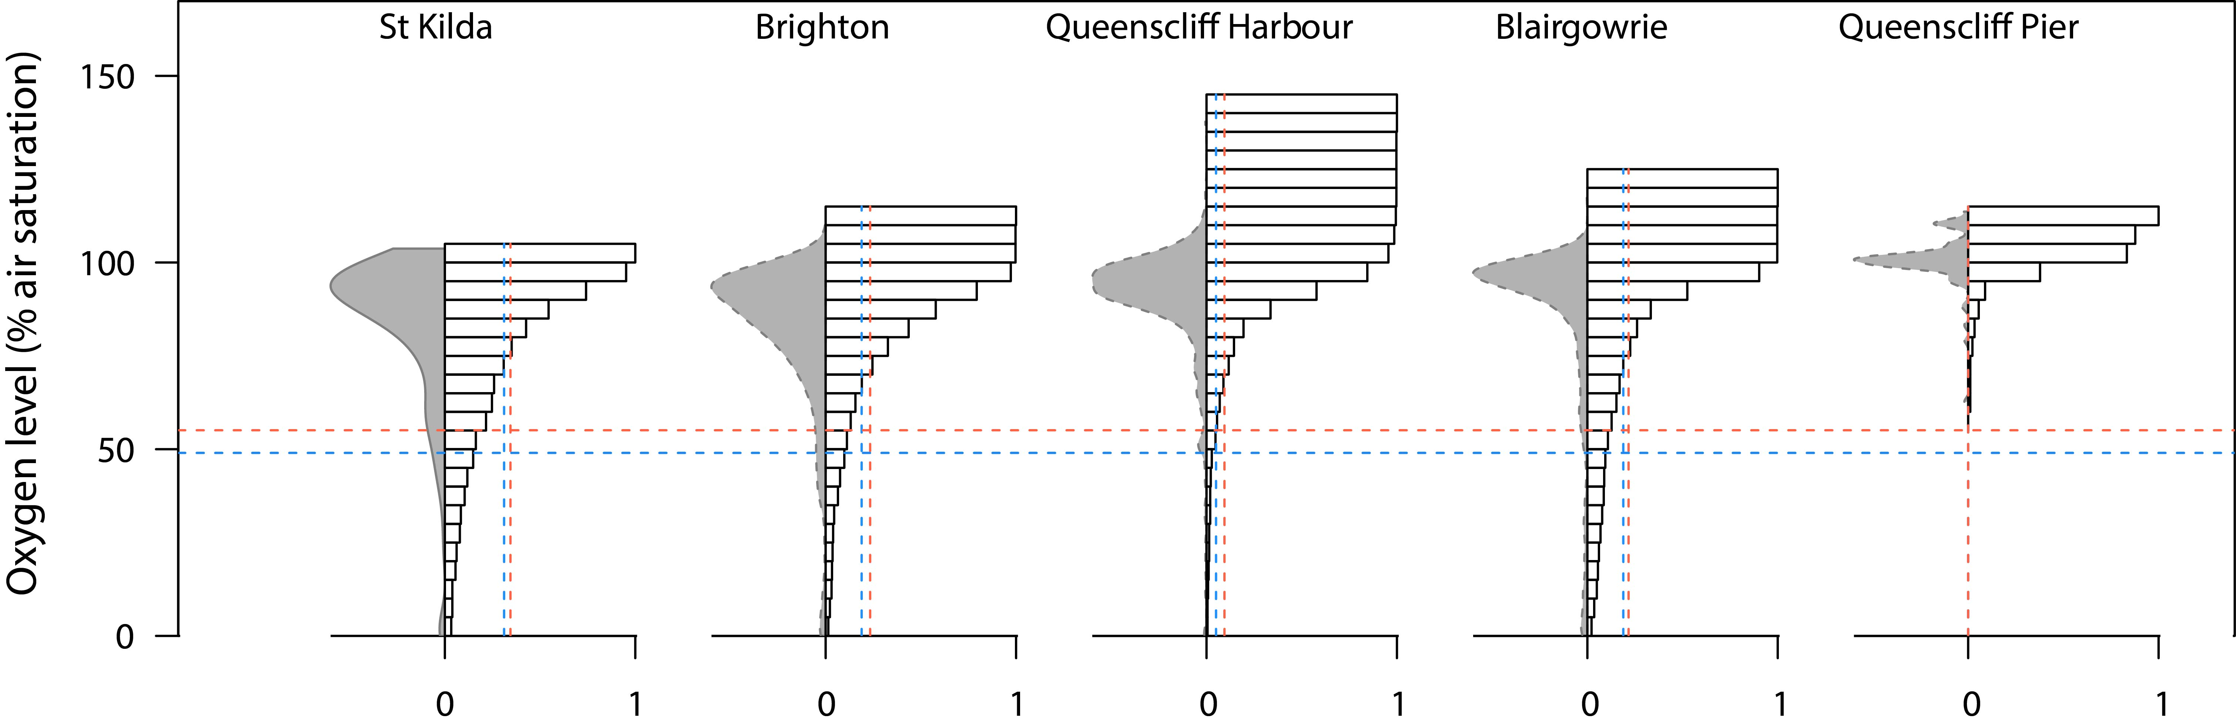FIGURE 1. Distribution of oxygen level across five different marine sites. Field sites are ordered according to their ranking of their average water speed, from slowest to fastest. Left side of each plot represent frequency distribution of oxygen. Right sides of the plots show cumulative density histograms of oxygen availability for each site. Vertical dashed lines indicate the points where the native and invasive organisms begin to suffer physiologic stress (i.e. the value of air saturation in which oxygen consumption is 5% lower than that at 100% air saturation). The horizontal lines correspond to the percentage of microsites that represent physiology stress due to oxygen limitation for native and invasive species form each site. Blue lines are for invasive organisms and red for natives.

FIGURE 2.:Differences in $C_{50\%\dot{V}O_{2}}$ between: A) species shape (erect and flat), and B) species status (native and invasive). Each of the 3,000 circles for each category represents an average of $C_{50\%\dot{V}O_{2}}$ estimated by an ANOVA using species-specific values of $C_{50\%\dot{V}O_{2}}$ drawn from MCMC samples from a Michaelis-Menten function fitted in *JAGS*.

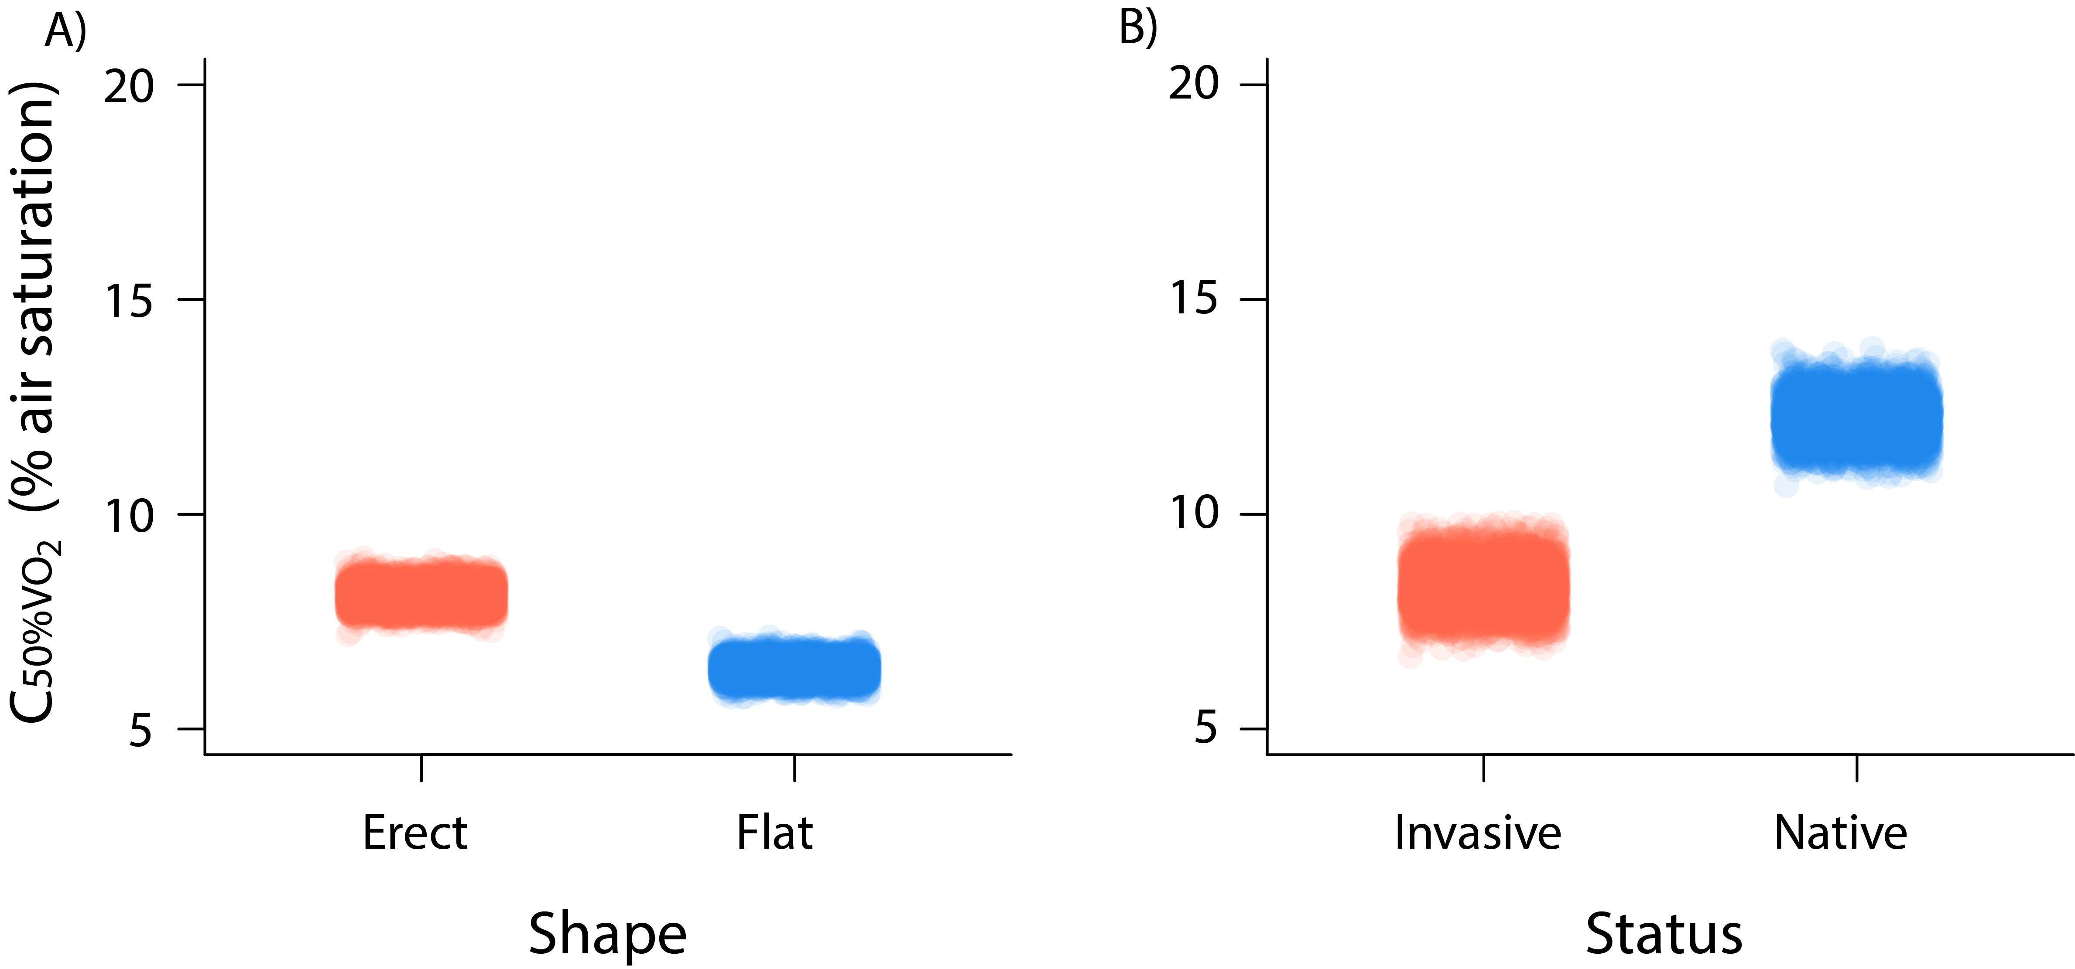

FIGURE 3. Differences in of $C_{50\%\dot{V}O_{2}}$ between status (native and invasive) for “erect shaped species” only. Each of the 3,000 circles for each category represents an average of $C_{50\%\dot{V}O_{2}}$ estimated by an ANOVA using species-specific values of $C_{50\%\dot{V}O_{2}}$ drawn from MCMC samples from a Michaelis-Menten function fitted in *JAGS*.

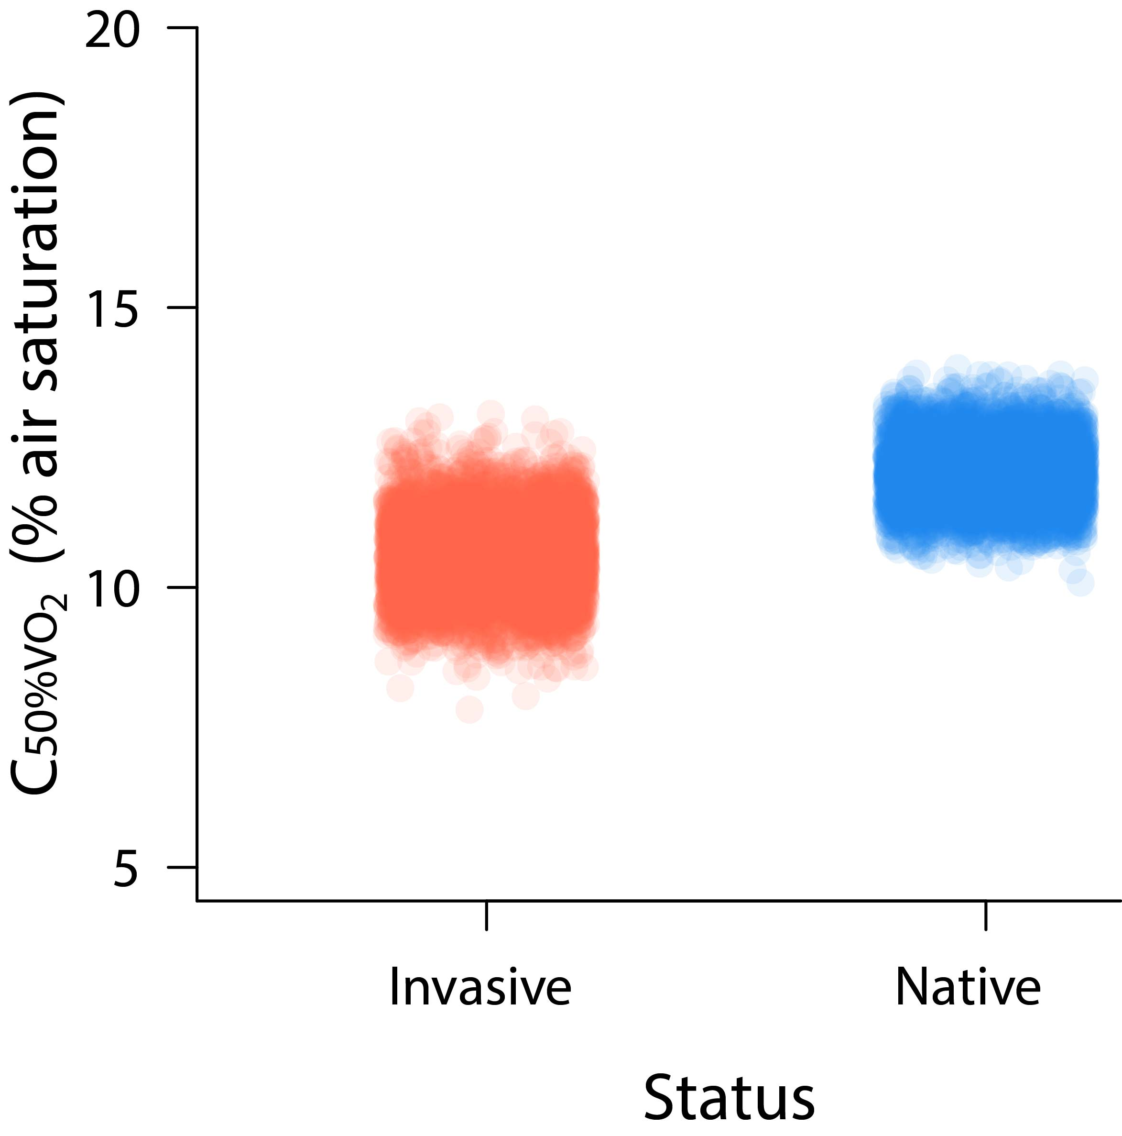

APPENDICES. Plots of oxygen level (% air saturation) with relative respiration rate of each species measured ($\dot{V}O_{2}$, 0-1). The intersection of dashed lines with x-axis shows the calculated $C_{50\%\dot{V}O_{2}}$.